# NAME : KAIF MOHAMMAD

# ROLL NO. : 20SW054

# SECTION : II

## ASSIGNMENT OF LAB 1,2,3

# LAB 1 :

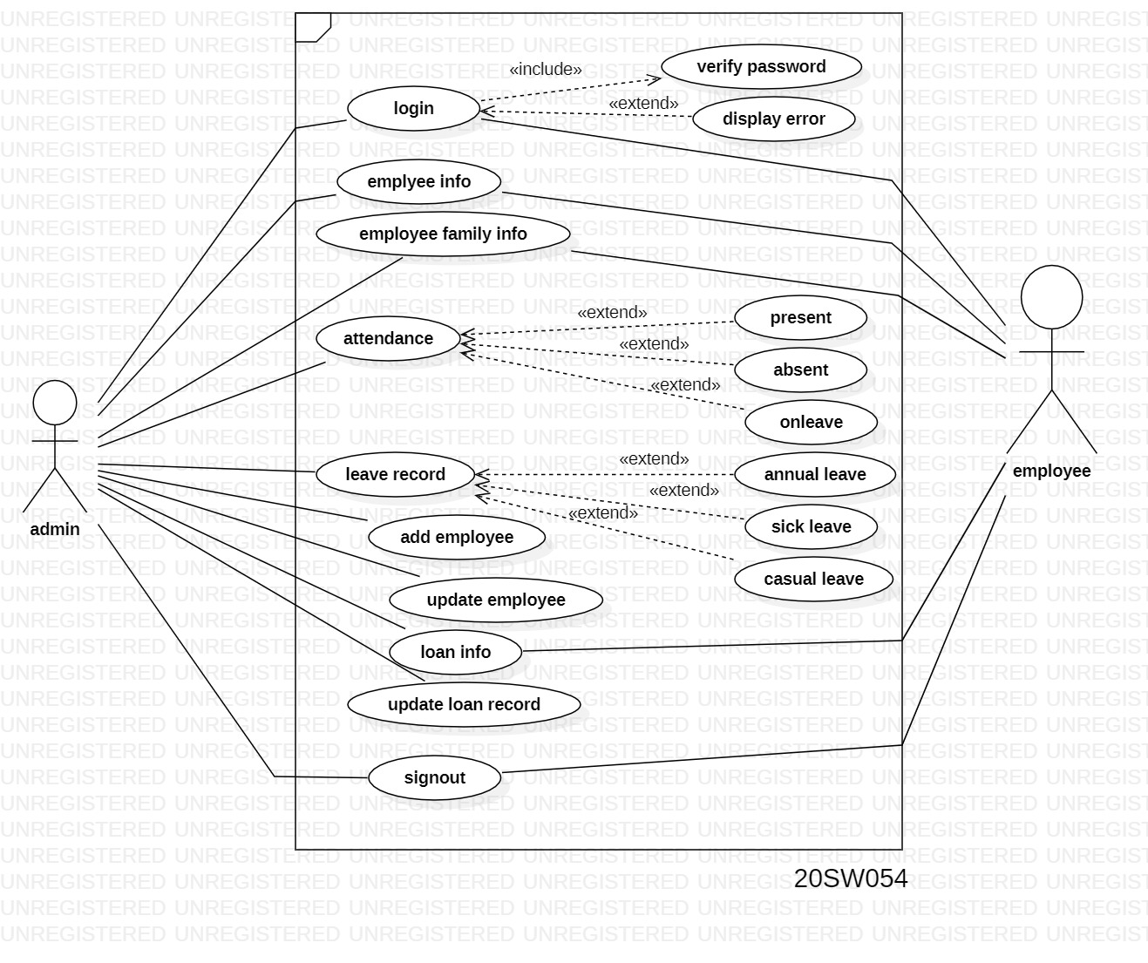

# LAB 2:

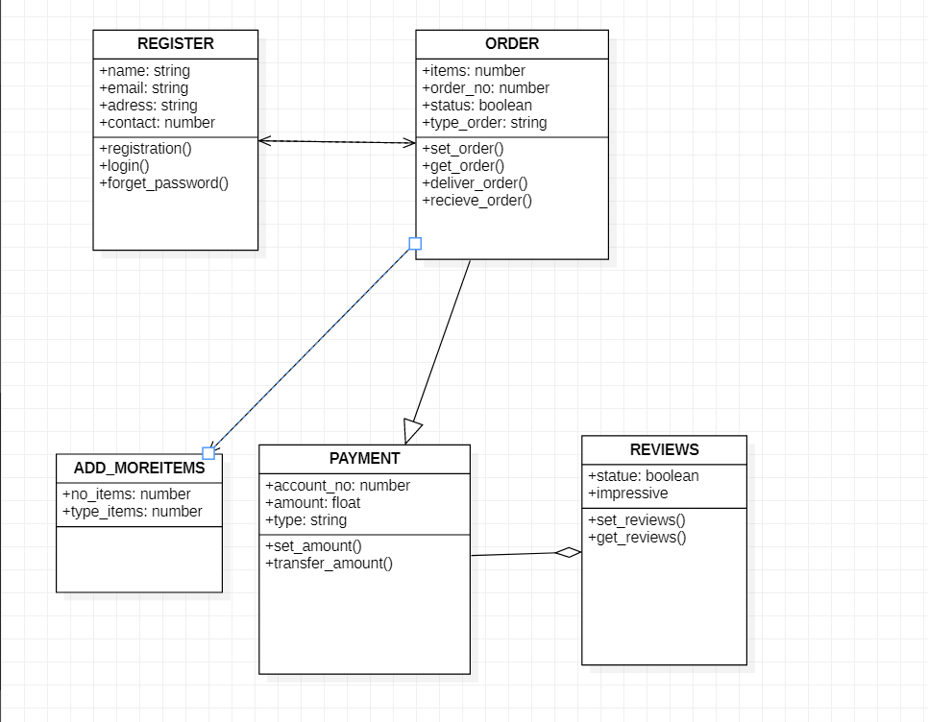

CODE:

class register{

public String name;

public String email;

public String address;

public int contact;

public void registers() {

}

public void login() {

}

public void forget_password(){

}

}

class order{

public int items;

public int order_no;

public String type;

public boolean status;

public void set_order(){

}

public void get_order() {}

public void deliver_order() {

}

public void recieve_order() {

}

}

class Add_more_items{

int no_items;

public String type_items;

public void add() {

}

public void Remove() {

}

}

class Payment{

public float amount;

public int account_no;

public String type;

public void set_account() {public void transfer_amount() {

}

}

class reviews{

public boolean status;

public String mess;

public String reaction;

public void set_Reviws() {

}

public void get_Reviws() {

}

public void remove_reviews() {

}

}

public class pizza {

}

## LAB 3:

